HALF ADDER

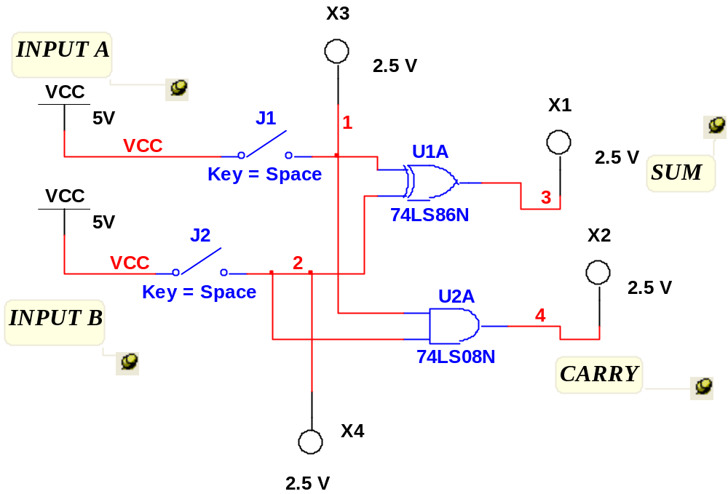

FULL ADDER

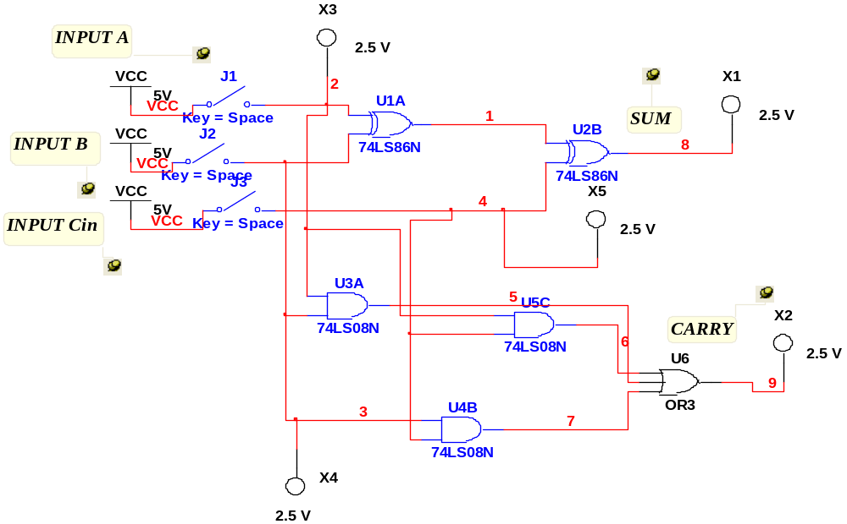

\
DESIGN OF HALF ADDER WITH BLACK BOX

- Go to MISC Digital and go to TIL and Type HALF_ADDER as shown below.
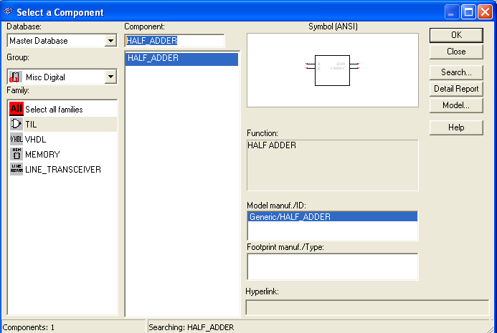

- Place the black box in the work sheet and connect switches, power supplies and Probes as shown below and start the simulation.

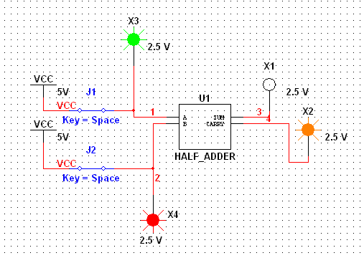

\
DESIGN OF FULL ADDER WITH BLACK BOX

- Go to MISC Digital and go to TIL and Type FULL_ADDER as shown below.
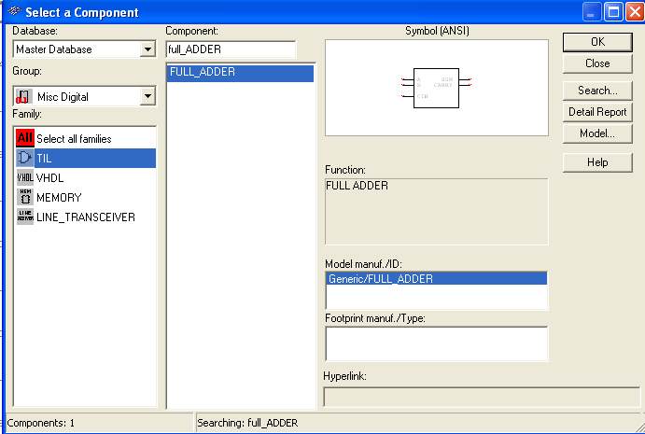

- Place the black box in the work sheet and connect switches, power supplies and Probes as shown below and start the simulation.
